Design patterns

Singleton - src/main/java/org/jabref/gui/externalfiletype

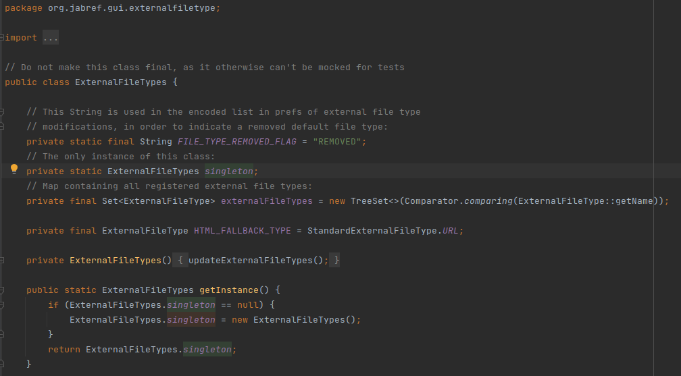

Chain of Responsibility Design Pattern - src/main/java/org/jabref/gui/FallbackExceptionHandler.java

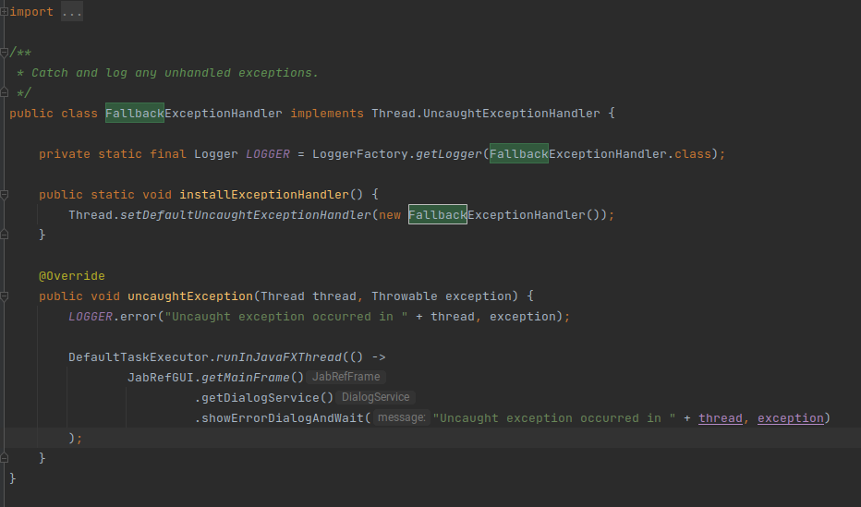

Template method pattern - src/test/java/org/jabref/logic/importer/fetcher

